**RF BASED HOME AUTOMATION SYSTEM**

**ABSTRACT**

The main objective of this project is to develop a home automation system with a RF controlled remote. As technology is advancing so houses are also getting smarter. Modern houses are gradually shifting from conventional switches to centralized control system, involving RF controlled switches. Presently, conventional wall switches located in different parts of the house makes it difficult for the user to go near them to operate. Even more it becomes more difficult for the elderly or physically handicapped people to do so. Remote controlled home automation system provides a simpler solution with RF technology.

In order to achieve this, a RF remote is interfaced to the microcontroller on transmitter side which sends ON/OFF commands to the receiver where loads are connected. By operating the specified remote switch on the transmitter, the loads can be turned ON/OFF remotely through wireless technology. The microcontroller used here is of 8051 family. The loads are interfaced to the microcontroller using opto-isolators and triacs.

**BLOCK DIAGRAM**

**TRANSMITTER**

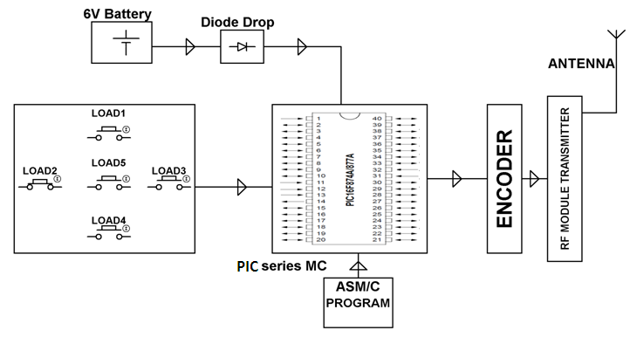

**RECEIVER**

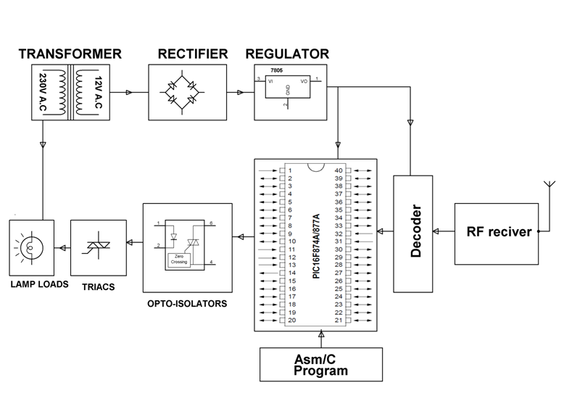

**HARDWARE REQUIREMENTS:**

PIC series Microcontroller, Transformer, Opto-isolator, TRIAC, Voltage Regulator, Crystal, Diodes, Resistors, Capacitors, Lamps, RF modules, Push Buttons.

**SOFTWARE REQUIREMENTS:**

HI-TECH PICC Tool suite

Languages: Embedded C or Assembly